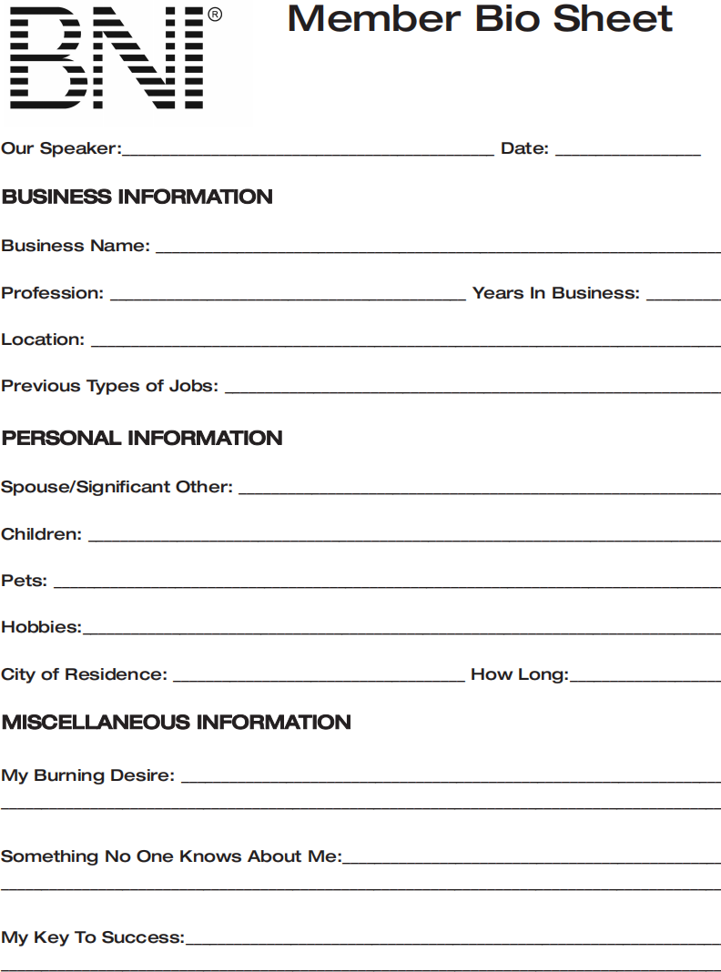

Suguna Consultancy Insurance

Insurance 25
Old washermanpet
Travels and Agriculture

Agastheeswarar helth and wellness Pvt Ltd

Daughter: Deloitte, Son: SRM biotechnology

Cats

Badminton

Chennai 30

Galaxy Club member in LIC

Best Tutor

